SIMATS ENGIN EERING
SAVEETHA INSTITUTE OF MEDICAL AND TECHNICAL SCIENCES

EXPERIMENT 03
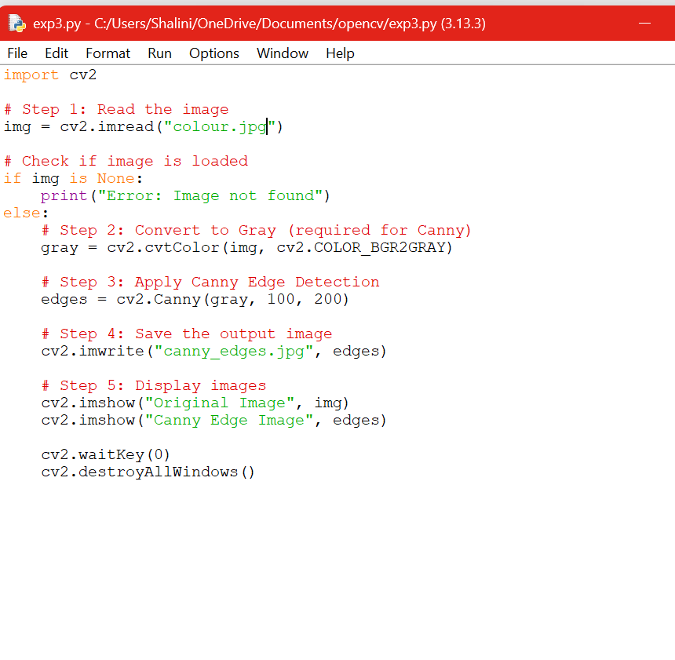
OUTPUT:
